Chapter 7, Problem 69.

For the op amp circuit in Fig. 7.134, find v_{o}(t) for t > 0.

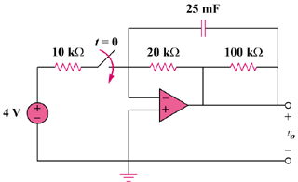

Figure 7.134
For Prob. 7.69.

